1. Find out the optimum reheat pressure of simple ideal Rankine cycle working between boiler pressure of 180 bar and condenser pressure of 0.05 bar if the maximum temperature is 500 degrees and keeping the operation of the turbine safe.

Using EES

The Problem is Solved as the following

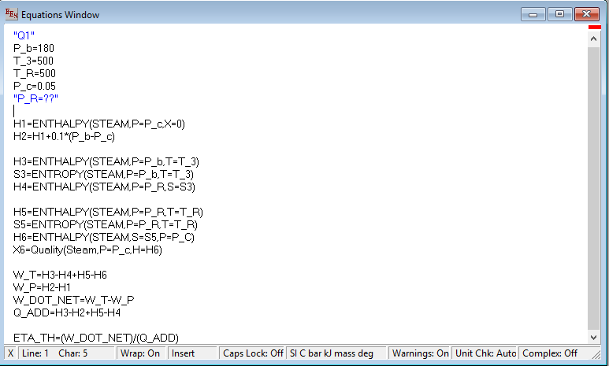

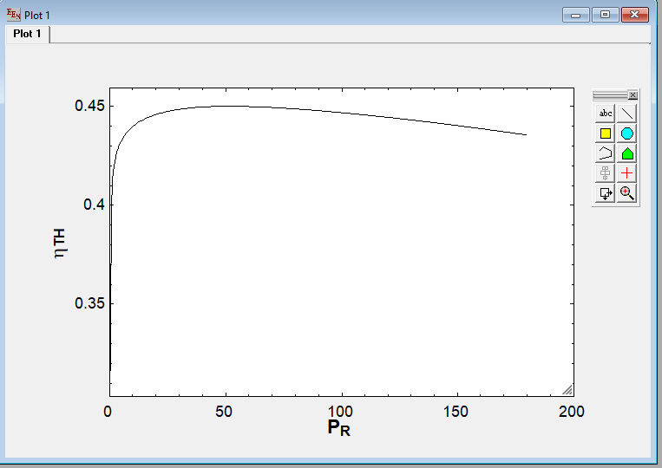Using table method in EES to vary the value of Reheat Pressure we found that best reheat pressure to get best efficiency

As chart shows

And using tables to check the safety also

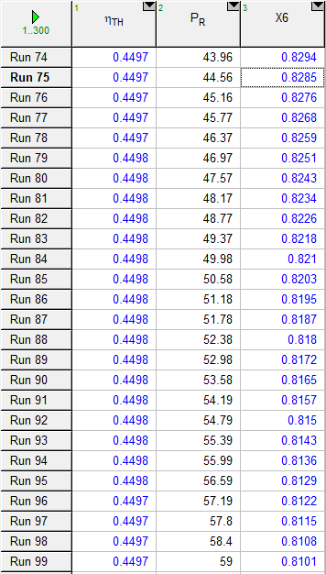

We found best efficiency will be within range of **Pressure of reheat** is **46.97** to **56.59** **bar** so the **efficiency** is max with value of **0.4498=44.98%** but on the other hand that not safe as in the best case when **P=46.97 bar** and **efficiency=0.4498** the **dryness fraction X=82.51%** and that is **unsafe** for turbine blades

So we put the quality of output steam in considers and get it value **>=0.95**

Which in it’s best cases we will have the **pressure** at **6.053 bar** and then the **efficiency** will be **43.45%** and steam **quality** here **X=95.01%** which is **safe**

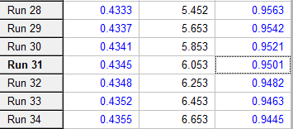

It also can be solved with EES to get the best safe value directly using if condition

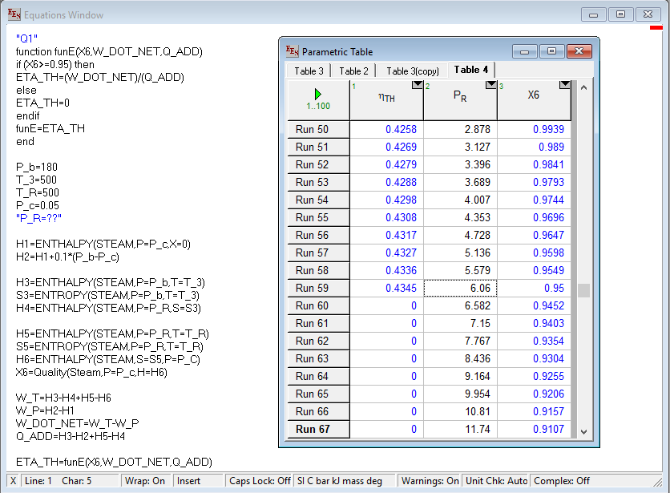as we used if condition we got the most accurate and **ignore** any **unsafe** results by make their efficiency is Zero so the **Optimum** and **safe** value of **pressure** is **6.06 Bar** and having **efficiency** of **43.45%**